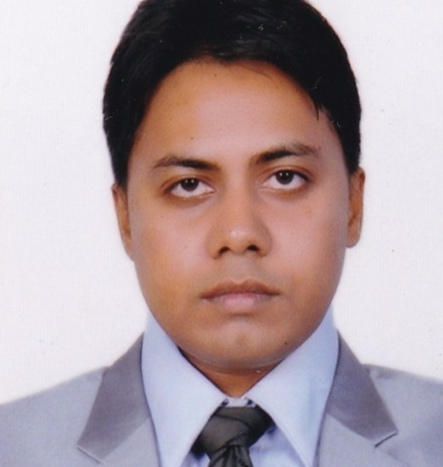Date:

To

The Managing Director

**Sub: Prayer for the post of Medical Officer /GP Specialist /Clinical Manager/AD/Director.**

Sir,

With all due respect I would like to state that I am Dr. Md. Mizanur Rahman. I have passed MBBS(DU) from Northern International Medical College Hospital (NIMCH) in July 2013 and have successfully completed my Internship from the same institution (BM&DC **Registration No: 70777** ) . Now I am interested to get job as a Medical Officer in your hospital. I will spend the time and give full effort to meet the professional goals of your organization and have enclosed my resume for your review.

I therefore pray and hope that you would be kind enough to appoint me and oblige thereby.

Sincerely Yours,

**Dr. Md.** *Mizanur Rahman*

**MBBS (Dhaka)**

**Cell: +8801675751795**

**E-mail:** [**mizan768@gmail.com**](mailto:mizan768@gmail.com)

**Dr.** *Md. Mizanur Rahman*

**MBBS (Dhaka)**

23/2 Gongaram Bazar ,Lalbagh, Dhaka-1211

Cell: 01675751795

E-mail: [**mizan768@gmail.com**](mailto:mizan768@gmail.com)

**RESUME**

**Career Objective:** .

To work in such a synergic and challenging environment where I can utilize my education in a proper way and in an atmosphere where there is an opportunity of self assessments and improvement in both individual and group based work that ultimately leads to a better success.

**Academic Status:** .

* **Secondary School Certificate (S.S.C)**
* Institute : Banladesh Rifles Public School & College
* Passing Year :2004
* Board : Dhaka

.

* **Higher Secondary School Certificate (H. S. C)**
* Institute : Bangladesh Rifles Public School & College
* Passing Year : 2006
* Board : Dhaka
* **Bachelor of Medicine and Bachelor of Surgery (MBBS) :**
* Institute: Northern International Medical College, Dhanmondi, Dhaka
* Subject: Medicine, Surgery, Gynae & Obstetrics
* Passing Year: July 2013
* University: Dhaka University

**Experience:**

I have been working in Liver Gastro Hospital as Medical Officer from …………………….

**Training:**

**Training:**  .

* **One year internship training** at Northern International Medical College & Hospital under the following Professors :
* Medicine : Under Prof. Dr. Md. Fazlul Hoque
* Paeditrics : Under Assoc. Prof. Dr. B. H. Nazma Yasmeen
* Surgery : Under Prof. Dr. Abdul Malek
* Gynae & Obst : Under Prof. Dr. Suraiya Begum

**Experience**:

1. **Comprehensive Training Course on COVID-19, Organized by John Hopkins Health Center ,BSMMU,IEDCR ,MOHFW and Govt. of the People’s Republic of Bangladesh.**
2. **Hospital Acquired Infection Prevention, Organized by icddrb.**
3. **Safe blood Transfusion, Organized by DGHS .**

**CLINICAL EXPERIENCES:**

1. **HMO (Dhaka Medical College Hospital),Dhaka.**
2. **Medical officer in Medi Aid Hospital Ltd ,Kolabagan ,Dhaka .**
3. **Medical officer (Medical check up) @ Healthcare Centre, Panthopath ,Dhaka**
4. **Physician @ Dhaka central Medical Services and Health Aid Hospital (OPD-Medicine),Dhaka**
5. **Assistant Physician under Prof.Dr.A.k.Md. Ahsan Ali (TB and Chest Specialist ,Ex director ,NIDCH) OPD at evening(6- 9 PM) .**
6. **DLP(Diabetology) From BIRDEM Hospital and DLP(Cardiology) from ICHRI(Ibrahim Cardiac Hospital and Research Institute).**

**Skills:**  .

**Computer Knowledge**

**Microsoft Office, Internet Browsing ,Email, Skype,Zoom,Whats App,IMO, Software setup.**

**Language Knowledge**

* **Able to read and Speaks Bengali , English and Hindi well.**

**Personal Quality:**  .

* Capable of adapting in any type of environment
* Dynamic and self-motivation
* Ability to cope with people at every level
* Skills at various kind of sports such as : Cricket , Football, Badminton, Pool-Billiard

**Personal Profile: .**

* **Father’s Name : Md. Shahid**
* Mother’s Name : Mst. Nazma Begum

Permanent Address : 23/2 Gongaram Bazar, Lalbagh, Dhaka-1211

* Nationality : Bangladeshi (by Birth)
* Marital Status : Married
* Date of Birth : **27/12/1989.**
* Religion : Islam (Sunni)
* Blood Group : ‘B’ (+ve)
* Height : 167cm
* Weight : 61Kg
* Contract : **Cell- 01675751795**
* National ID No. :  **7757386953**
* Passport no. **: BF0395609**
* Skype- : msajid987

**Reference: .**

* **Prof. Dr. Md. Fazlul Hoque**

( M.B.B.S.;F.C.P.S.; F.R.C.P.)

Head of the dept. of Medicine

Northern International Medical College Hospital

House No # 84, Road No # 8/A (Old-15)

Dhanmondi, Dhaka -1209

**Cell: +88 01819-220694.**

* **Prof. Dr. Abdul Malek**

**(**M.B.B.S.; F.R.C.S. ; F.I.C.S.)

Head of the dept. of Surgery

Northern International Medical College Hospital

House No # 84, Road No # 8/A (Old-15)

Dhanmondi, Dhaka -1209

**Cell: +88 01711739700**

I, undersigned, declare that,to the best of my knowledge and belief,this resume correctly describe my qualifications and me as well.

**Dr. Md. Mizanur Rahman**

**Mobile- +8801675751795**

**Email- mizan768@gmail.com**